ACCREDITATION FORM
Chic-Boy™
DATE RECEIVED: __________________ LOCATION CODE: ______________

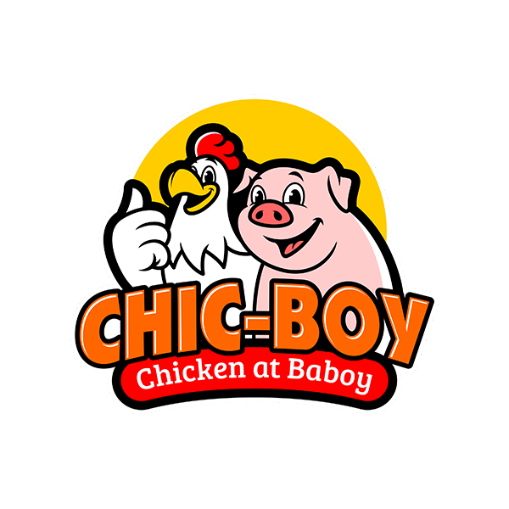

INSTRUCTIONS: Answer all questions completely; if question is not applicable, write “NA”. Use the blank space at the back of this form for extra details on any questions for which you do not have sufficient space. Type, print or write clearly and eligibly. Any illegible or incomplete forms will not receive consideration. Use legal size 8.5 x 14 bond paper to print.

--------------------------PLEASE DO NOT WRITE ABOVE THIS LINE – FILL UP ALL FIELDS BELOW ONLY--------------------------

PERSONAL INFORMATION
Last Name |  |  |  |  |  |  |  |  |  | First Name |  |  |  |  |  |  |  |  |  |  |  |  | Middle Name
Birth Date |  |  |  |  |  |  |  |  |  | Place of Birth |  |  |  |  |  |  |  |  |  |  |  |  | Citizenship
Work / Profession |  |  |  |  |  |  |  |  |  |  |  |  |  |  |  |  |  |  | Tax Payer ID No.(TIN)
Marital Status |  |  |  |  |  |  |  |  | First Name of Spouse |  |  |  |  |  |  |  |  |  |  |  |  | Maiden Name of Spouse
Mobile No 1 |  |  |  |  |  |  |  |  |  |  |  | Telephone |  |  |  |  |  |  |  |  |  | eMail 1
Mobile No 2 |  |  |  |  |  |  |  |  |  |  |  | Fax No |  |  |  |  |  |  |  |  |  | eMail 2
Home Address
Name of present Business
Kind of Business |  |  |  |  |  |  |  |  |  |  |  |  | Products or Services
Office Address
Office Tel No. |  |  |  |  |  |  |  |  |  |  | Fax No |  |  |  |  |  |  |  |  |  | Website
LIST BUSINESSES or FRANCHISE YOU ARE CURRENTLY ENGAGED IN
Business Name | Address | Kind of Business | Date started
CURRENT LOCATION NG LITSUNAN
Complete Address
Nearest landmarks
Describe location |  | (e.g. gated village sticker required, main road etc.
Total Floor Area | Sqm. |  |  | Frontage |  | meters |  | Owned Leased, if so, how much?
Nearest competitors
Target market or potential customers
Reason for choosing this location?
How did you learn about Chic-Boy Litsunan Accreditation?
NOTE: To help our site inspection team, please make a sketch of the location map on the back of this form.

I understand that the completion of this form places no obligation on me and does not imply my acceptance as a Cloud Kitchen Owner. This application is submitted to comply with one of the Company’s Pre-Qualification requirements. I certify that the above information is true and correct and I understand that any misrepresentation or omission of facts will affect my franchise application and / or terminate the agreement.

Franchise Applicant’s Signature over Printed Name Date Accomplished

Chic-Boy™ is a registered trademark and a subsidiary of Pier One Bar & Grill Holdings Corporation

CB-Form 01.01.21

